**BURGESS-PETERSON ACADEMY**

**Date: Thursday, January 7th, 2021**

**Time: 6:00 PM**

**Location: ZOOM**

**Meeting ID: 374-345-1598 Password: daw**

[**https://atlantapublicschools-us.zoom.us/j/3743451598?pwd=VENPT1FOcEkrc2xGc0xNa3M0Zk4vdz09#success**](https://atlantapublicschools-us.zoom.us/j/3743451598?pwd=VENPT1FOcEkrc2xGc0xNa3M0Zk4vdz09#success)

1. **Call to order –** Morgan King-Ray, 6:04
2. **Roll Call; Establish Quorum –** Quorum present by MKR’s account.

|  |  |  |
| --- | --- | --- |
|  | Morgan King-Ray | Present |
| Principal | David White | Present |
|  | Deangela Huggins | Present |
|  | Tolton Pace | Present |
|  | Mike Bland | Present |
| Secretary | Tracey Pendley | Present |
|  | Andre Pam | Present |
|  | Wendy Angelety | Present |
|  | Ashley Dyson | Present |
| Community Member | Anna Beale Smith | Present |
| Additional Attendees | Diane Jacobi |  |

1. **Action Items** *(add items as needed)*
   1. **Approval of Agenda -**  T. Pace motioned to approve, D. Huggins seconded.
   2. **Approval of Previous Minutes -** A. Dyson motioned to approve, seconded by W. Angelety
   3. **Action Item 1:** Approve Community Member Seat

* Action item moved ahead of Strategic Plan Approval per D.White.
* D.White gave a recommendation for the Community Member position on our Go Team, Ms. Anna Beale Smith. She has been a thought partner with D. White for a few years, and is an involved school community member.
* A. Beale spoke to the group. Her She works at the CDC, as an HIV prevention Social Worker.
* Mr. White’s nomination is Ms. Anna Beale Smith. Motion to approve by T. Pendley; Seconded by T. Pace.
  1. **Action Item 2:** Approve Strategic Plan Priorities for 2020-2021
* D. White shares that he examined the minutes thoroughly and adjusted language and data images in the new deck.
* Reviewed the Strategic Priorities and opened the group to discussion and questions.
* A. Dyson motioned to approve, Seconded by D. Huggins, T. Pace

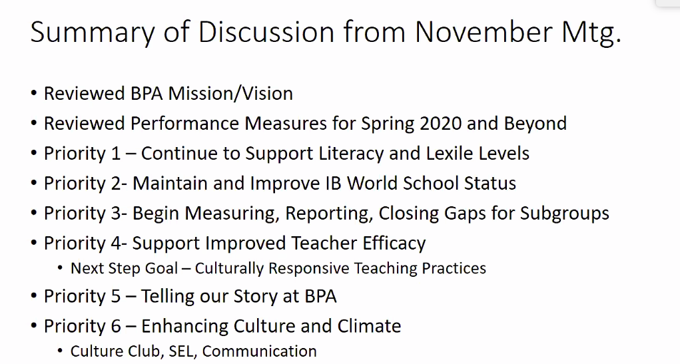

1. **Discussion/Information Items** *(add items as needed)*
   1. **Item 1**: Principal’s Updates Regarding Quarter 3 “Return + Learn”

D. White reviewed changes for students returning for Face to Face learning in Quarter 3. The window of Declaration has closed (Due 12/21).

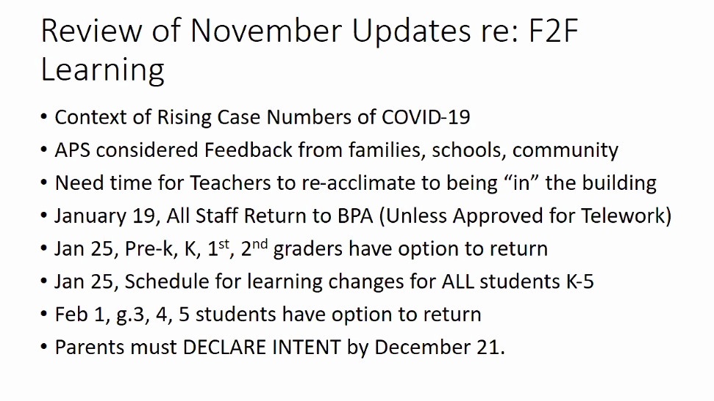

* Review of Face to Face Plan:

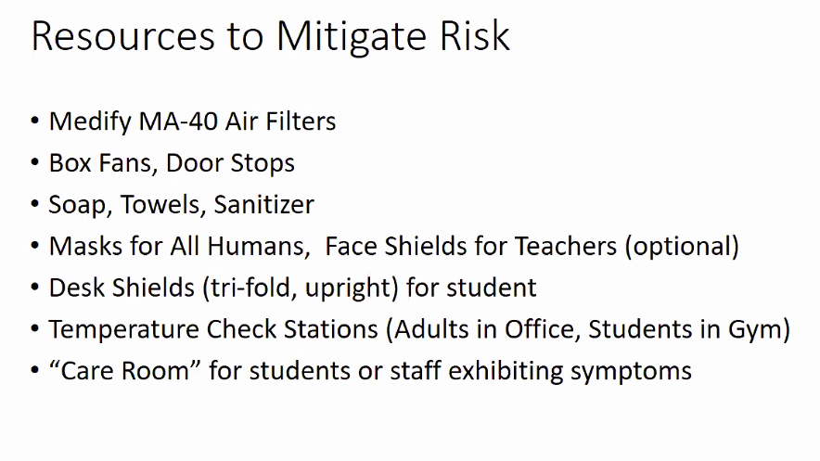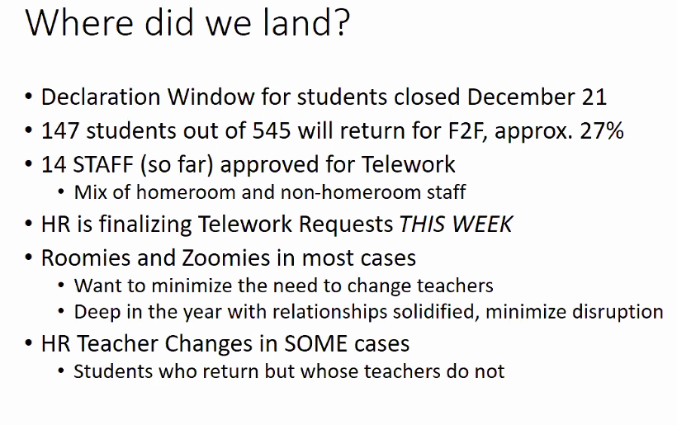147 students returning, about 20% of the student . Will provide space and ability to proceed with teaching and learning at a high level.

* + 14 staff members to date approved for telework.
  + Per D. White, Teachers will have to teach virtual and physical simultaneously. It is too late in the year to change teachers because of the relationships built.
* D. White and admin are preparing for the teachers’ and students’ return, wanting to build confidence for everyone involved. We have done many things to make safety a priority and have purchased several things to help with hygiene, social distancing, desk shields, etc.

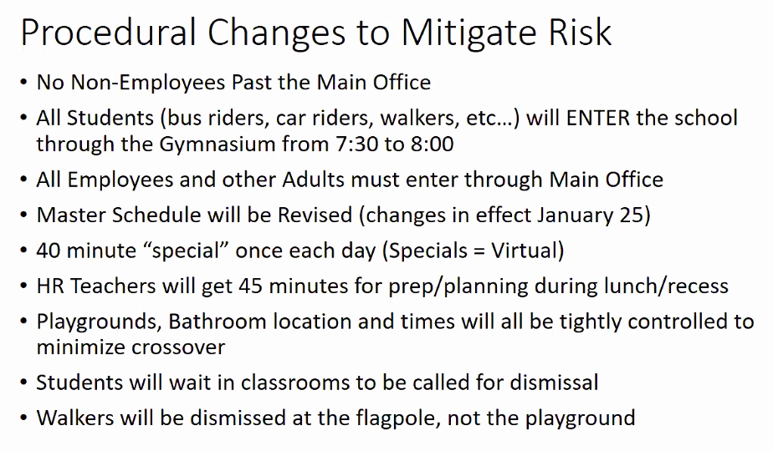

* Temperature Check stations; receiving 4 more before the return to school.
* The Care Room will be in the Band Room with the School Nurse. It is out of the flow and it has direct exit for pick-up.
* Every teacher will have their own temperature check gun; 2 x a day the teachers will take it and log it; as an extra measure of safety and caution.
* D. White will make a kid friendly video explaining new procedures.
* All of this is subject to change… we are moving forward as if all this is true – he expects that it will be true – but there’s always a chance that things could change.

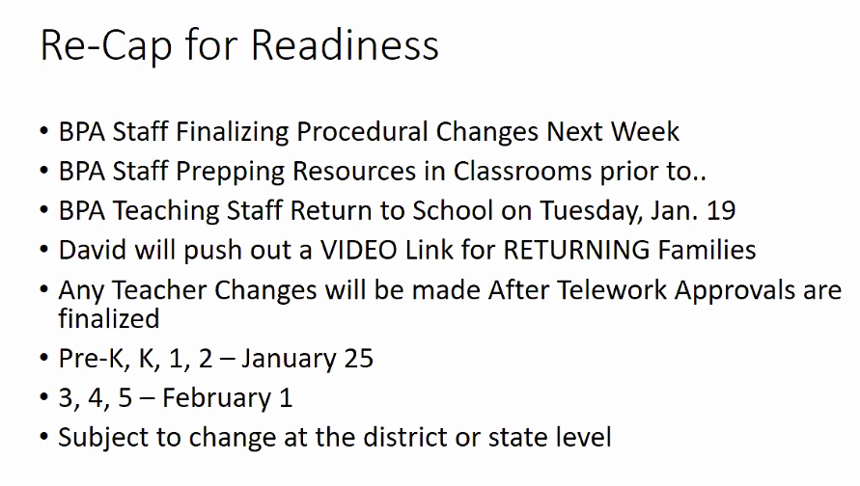

* D. White asked for thoughts and questions from the group:

Questions:

1. A. Beale asked about if we have kid-sized masks. D. White: Yes, 3,000 of them (and some of Mickey Mouse ☺).
2. A. Dyson asked if the Covid numbers determine return. “Are you stating that with the numbers currently, we’ll go back or?” D. White confirmed that the decision date has come and gone. We’re going back – even at the worse point of the pandemic. It is not his decision.

* W. Angelety, A. Dyson noted the inherent danger in returning at this point. At least it’s less than 30% of our students.

1. A. Dyson asked about roomies and zoomies – will physical students be there virtually or teaching physically to the group…. D. White responded that it will largely be virtual teaching. It is a difficult decision, with 80% of students virtual it is likely we’ll see physical students following along with their laptops.

D.White’s number one goal is that his teachers don’t go crazy and that teachers stay healthy. A .Beal Smith commented that this is a strong priority. Commented on importance of the fans; HEPA filters and importance of hygiene, filtration systems, ventilation, “much more likely that it happens in your living room or a restaurant.”

1. T. Pace asked re Nurse, is she itinerate or based at BPA? D. White responded that years ago she became full time. He negotiated her start time today – she will arrive at 7am and be the singular person taking temps and recording.

Follow up question from T. Pace: Re Cleaning procedures and the asynchronous day, what does the process look like on a day to day basis? D. White responded, -- Ms. Ware and Mr. Golden have a prioritized list of “high touch” spaces that they will wipe down several times a day. On Wednesdays, Mr. Pearson will use a fogger to disinfect.

1. A. Dyson asked if there is a substitute for the Nurse. We’ve always provided coverage from within the admin staff.
2. W. Angelety asked, what about students who are late? Will they go through the front office? D. White: Yes. Objective is to catch the bulk from 7:30-8:05 and then route through the front office.
3. Question from T. Pace, Has there been any shared community conversations around testing? Are they being encouraged to take tests? D. White responded that one of his staff members let him know tonight that APS is working towards making vaccinations a part of their reentry plan. Hoping that it is a real thing, and if it is – when, how, where, who? He will be checking in to given it was in the news today.

Short sidebar about how testing doesn’t always work because they can test positive for up to one month. A. Beal Smith spoke on testing in a nearby county for teachers and said it would be forward if teachers could test 3 times a week.

T. Pace offered that a group he works with has been working on getting people into the district – D. White offered a phone call to T. Pace for tomorrow. Asked that T. Pace send him some good times for a phone call.

1. Question from chat read by M. King-Ray: Has there been discussion about high traffic teacher areas and the front office? D. White responded with portions of our plan, including social distance stickers, a staff check list to make it quicker; staff will continue to utilize their phones to Kronos in; possible jam in the office at 5 til 8.
2. W. Angelety asked what the procedure is if there is COVID exposure in our school? D. White responded that the district has developed a document that speaks to that. It’s a tiered response based on the severity of the case based on time, location, exposure, etc. There is also a line of communication triggered for notification.
3. A. Pam asked a question about the front door and if Nurse will be the only person there. D. White responded that some times she may be, however at different times there may be other people helping her such as Q. Greer. D. White invited feedback about how the procedures will run in the front office.

* D. White thanked the group.
* M. King-Ray asked if there was anything else we can do to support him in this work? D. White said he’ll begin sharing information about this on Monday, and that helping/reinforcing the messaging from him and his team is always helpful. Always direct questions to D. White if there are questions asked of us that we don’t know the answers to.
* A. Dyson asked if everyone is aware about the schedule change coming up on January 25th? D. White responded that it sounds like we need to amp that up – schedule changes for everyone, not just students returning physically.

*\*\*\* This should be added to D. White’s notes for Morning Meeting. \*\*\**

Question asked about Go Team Orientations, trainings; You do not have one on your second year; M. King Ray responded only had a training this year if if you’re an officer or it is your first year.

1. **Announcements** –
   1. Next meeting is 2/18 at 6pm. Budget is likely an agenda item
   2. Targeted Intervention Program ended today. Only moderately successful; averaged 8-10 students a day, we invited 25. Meals served during TIP was concerning. We don’t expect our kitchen to be open like schools that have higher percentages of students returning. If the quality of satellite meals does not improve, he will ask for the support of this group. Not time to raise the equity flag yet – let’s wait and see if we’re all getting the same thing or not. T. Pace commented on pushing the topic of nutrition and healthy meals in the kitchen. What does it look like to redirect those funds to someone who will give quality meals? Will discuss tomorrow.
   3. D. White shared that this is the first year we’ve had to apply for free or reduced lunch rate. Our current rate is %14. We’re going from 150K Title I dollars to 30K Title I dollars. This does not seem accurate. We should be in 30-40% Free or Reduced lunch bracket. We need to make sure applications are completed. We will be a “Targeted Assistance School” when it drops below the threshold.
   4. A. Dyson asked about the students that attend the TIP program. D. White responded that they are students who were not consistently present online. We learned that poor attendance was because some lived too far out, participation, many other factors.
   5. Congratulations to SERGEANT PAM!!!!!!
2. **Public Comment**
3. **Adjournment –** Morgan King-Ray introduced adjournment --- Motion to end the meeting by T. Pace, Seconded by W. Angelety.

**Ended at 7:31pm.**